GENERAL INFORMATION

City area 157 sq.km
Population 297,8 thous.
(2016 01 01)

Density 1897,1 person/sq.km
(2016 01 01)
Geography:
North latitude 54º 56 '
East longitude 24º 51'
Elevation 24 – 90 m above the sea level

Distance from Kaunas to Vilnius (the capital) –103 km,
to Klaipėda (the seaport) – 209 km
Climate (in 2015):
Average annual temperature 8,7 ºC
Average temperature in July 17,4 ºC
Annual precipitation 552 mm

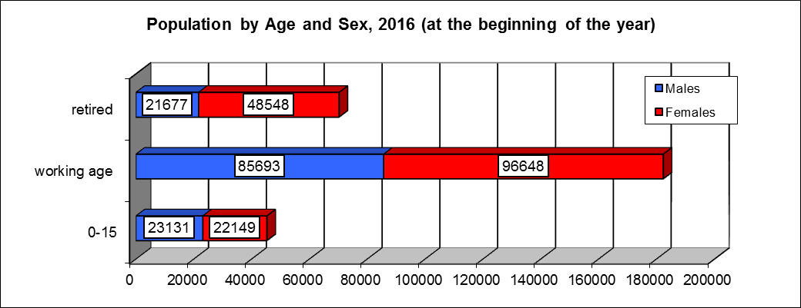

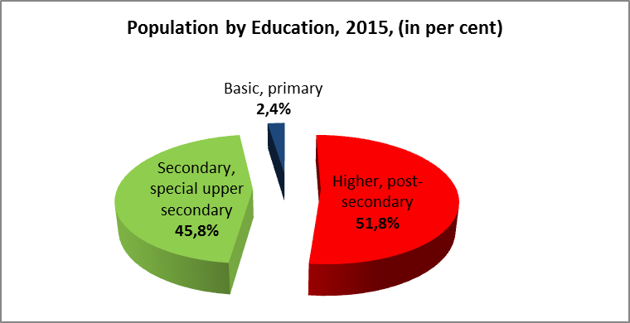

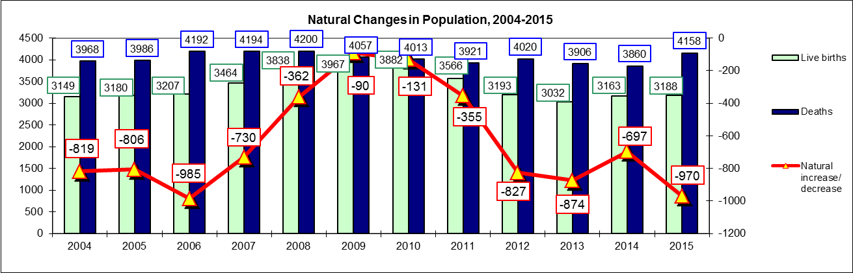

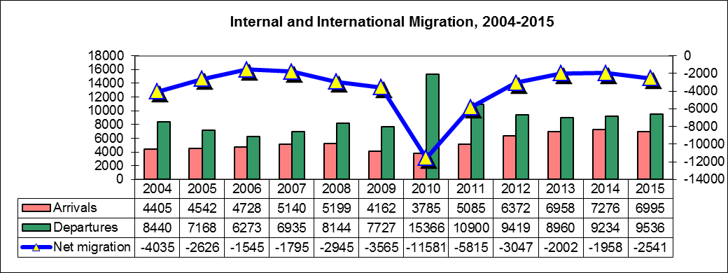

EDUCATION
Kaunas has 4 universities, 5 colleges, 8 vocational schools. Total number of students studying in vocational schools, colleges, universities (2014-2015) is 48838.

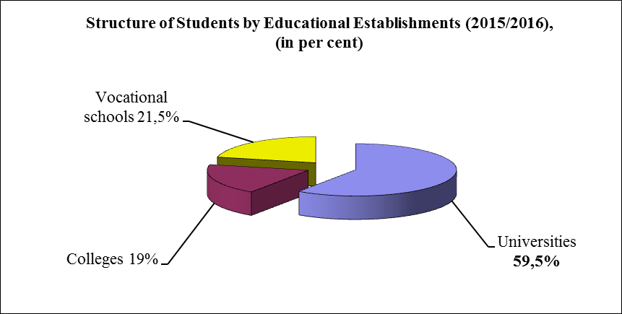

ECONOMIC ACTIVITY

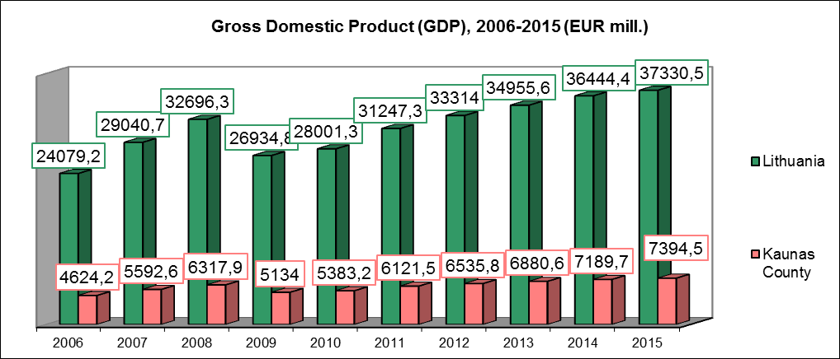

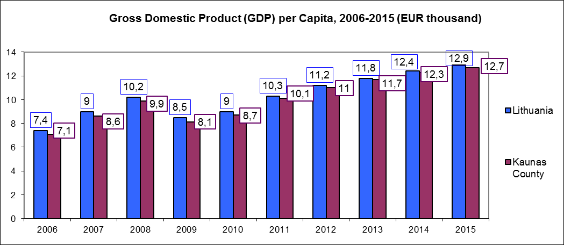

52 % of Kaunas County residents live in the city of Kaunas. 55,2 % of Kaunas County employed persons are residents of Kaunas (2015).

Existing Economic Entities 2016 01 01:
Grand total in Lithuania – 99200
Kaunas County – 19857
Kaunas – 13676

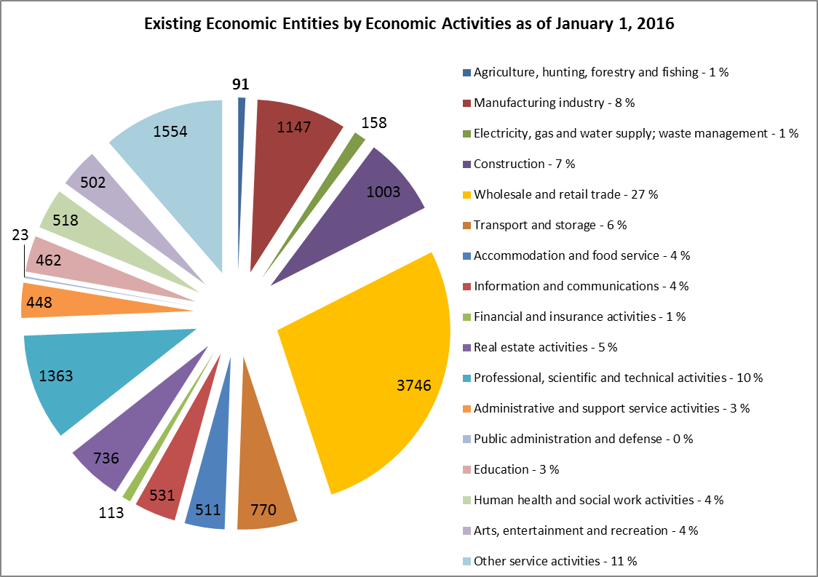

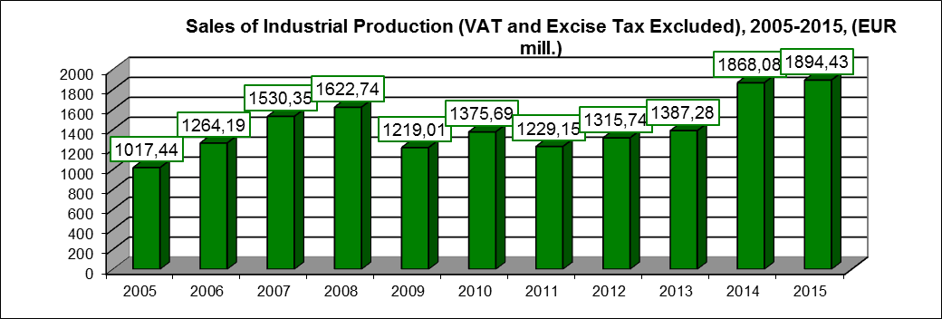

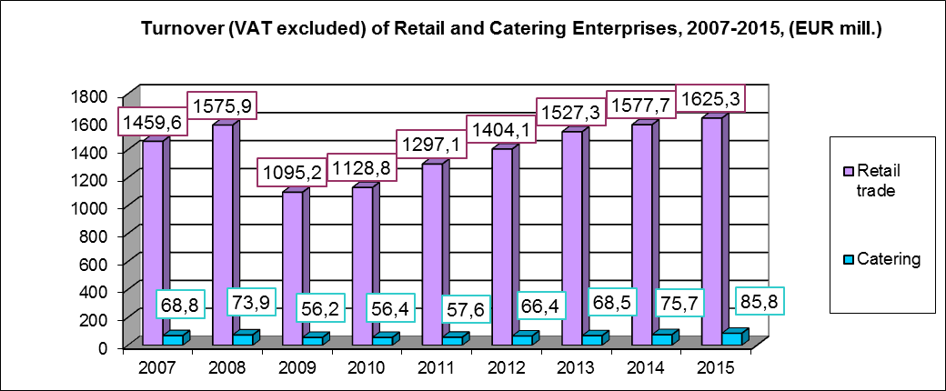

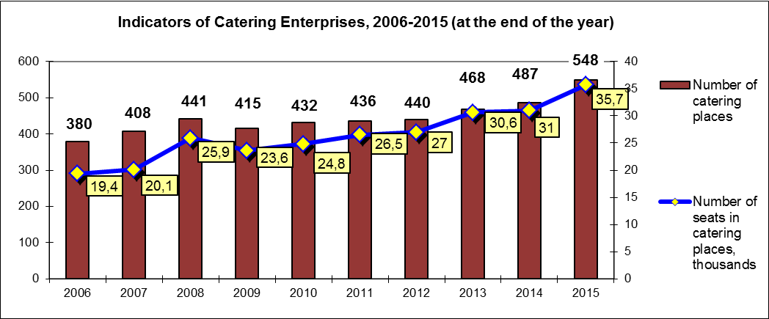

Sales and Services of Industrial Production in 2015, (EUR mill.)

 | Exports | Sales on the Lithuanian market
Other mining and quarrying | 0,1 | 5,2
Food production | 142,5 | 357,1
Beverages | 42,5 | 101,1
Textile articles | 68,3 | 19,5
Making of wearing apparel | 106,3 | 34,2
Lather products | 1,1 | 1,3
Wood and cork | 3,1 | 6
Paper and paper products | 31,4 | 40,5
Printing and reproduction of recorded media | 11,2 | 17,2
Chemicals and chemical products | 27,3 | 10,5
Basic pharmaceutical products and pharmaceutical preparations | 4,3 | 4,2
Rubber and plastic products | 32,5 | 39,2
Non-metallic mineral products | 13,8 | 45,9
Basic metals | 38,5 | 7,4
Metal products | 60,5 | 92,6
Computers, electronic and optical instruments | 27,9 | 16,4
Electrics | 22,5 | 4,7
Other machinery and equipment | 80,9 | 7,3
Motor vehicles, trailers and semi-trailers | 45,6 | 1,2
Other transport equipment | 11,7 | 1,6
Furniture | 208,7 | 19,3
Others products of industry | 13,2 | 13
Machinery and equipment, repair | 9,2 | 45,7

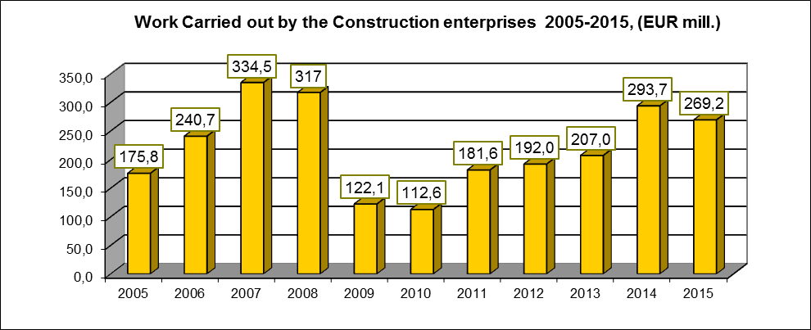

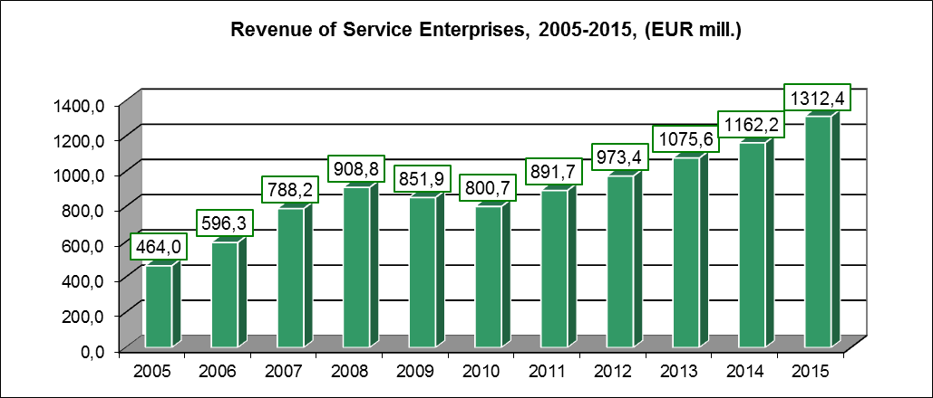

THE LARGEST KAUNAS COMPANIES , 2015

No. | Company | Field of activity | Sales revenue in 2015, (EUR. mill)
1. | Senukų prekybos centras, UAB | Wholesale and retail trade | 320
2. | Kauno grūdai, AB | Manufacturing | 316,3
3. | Top Sport, UAB | Arts, entertainment and recreation | 209,5
4. | Agrokoncerno grūdai, UAB | Wholesale and retail trade | 193,5
5. | ACC Distribution, UAB | Wholesale and retail trade | 189,8
6. | Nemuno vaistinė UAB | Wholesale and retail trade | 147,9
7. | Kauno tiltai,AB | Construction | 135,4
8. | Lytagra, AB | Agriculture, hunting, forestry and fishing | 125,1
9. | Agrokoncernas, UAB | Wholesale and retail trade | 121,3
10. | AVAD Baltic, UAB | Wholesale and retail trade | 120,9
11. | Vičiūnai ir Ko, UAB | Wholesale and retail trade | 114,4
12. | Tete-a-tete kazino, UAB | Arts, entertainment and recreation | 107,7
13. | Freda, AB | Manufacturing | 84,8
14. | Lemora, UAB | Wholesale and retail trade | 71,9
15. | Dineras, UAB | Wholesale and retail trade | 70,8
16. | Mitnija, UAB | Construction | 63,1
17. | Kauno energija, AB | Power and heat generation and supply | 60,7
18. | Tamro, UAB | Wholesale and retail trade | 60,1
19. | Hegelmann transporte, UAB | Transport and storage | 58,1
20. | Okseta, UAB | Real estate activities | 52,7

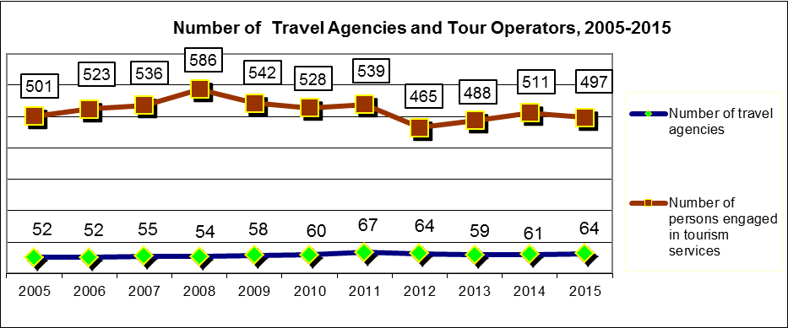

Hotels, Motels And Their Activities in 2012-2015

 | 2012 | 2013 | 2014 | 2015
Number of enterprises | 60 | 77 | 100 | 103
Number of rooms | 1 594 | 1 657 | 1 760 | 1 684
Number of beds | 3 331 | 3 713 | 3 930 | 3 644
Number of accommodated quests per year | 179 414 | 204 186 | 215 130 | 227 818
Foreigners among them | 128 493 | 138 250 | 145 993 | 150 750
Nights spent | 365 316 | 399 819 | 418 023 | 414 588
Nights spent by foreigners | 234 364 | 255 741 | 265 549 | 264 395

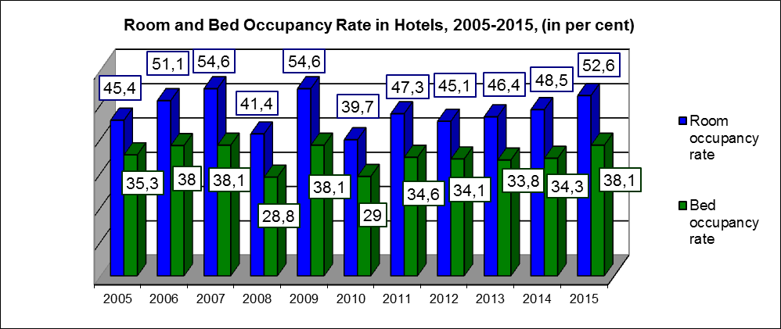

CITIZENS FROM THE FOLLOWING TEN FOREIGN COUNTRIES WERE THE MOST FREQUENT GUESTS OF THE ACCOMMODATION ENTERPRISES IN 2015: Germany, Russia, Latvia, Poland, Estonia, Finland, United Kingdom, Belarus,Ukraine, Italy.

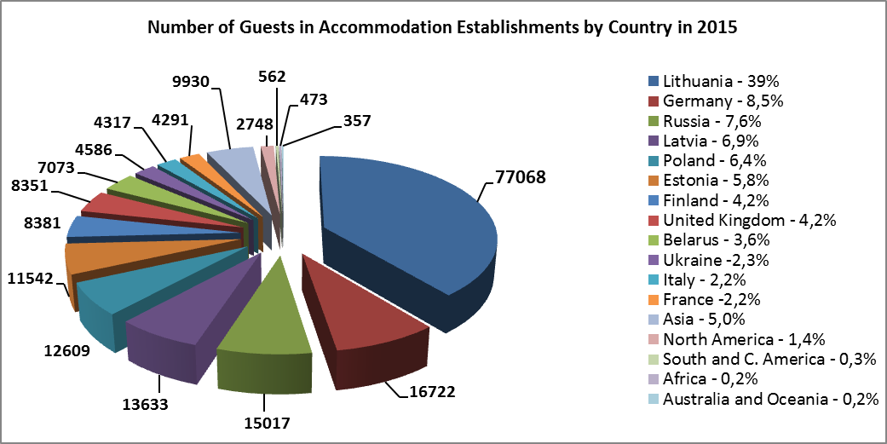

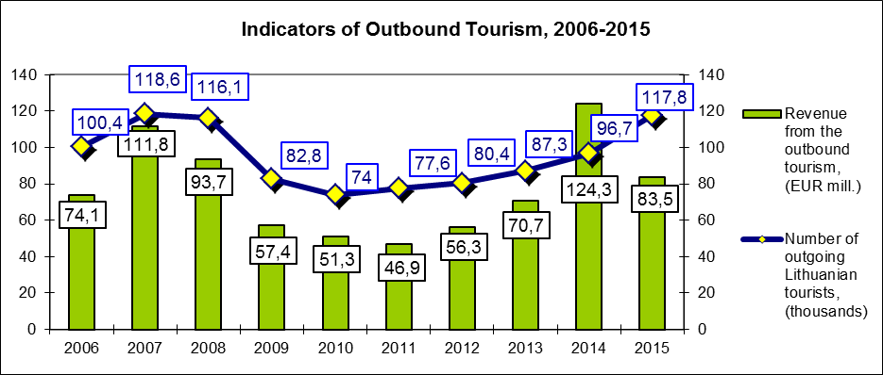

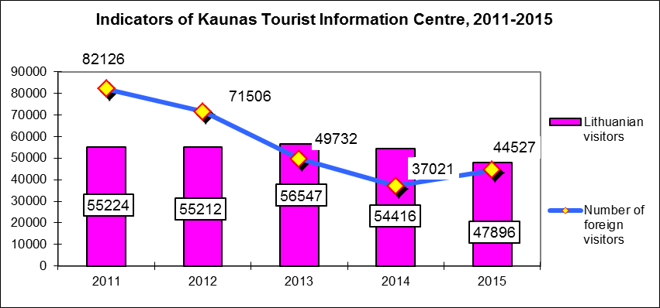

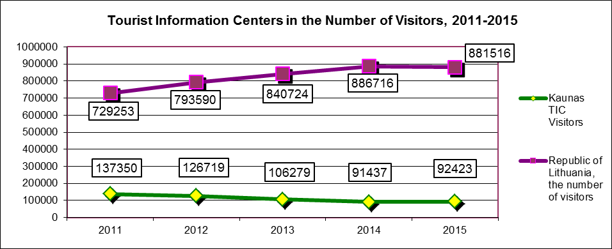

INVESTMENT

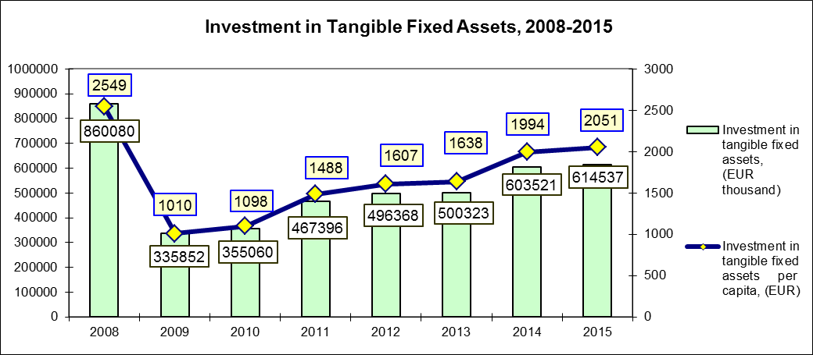

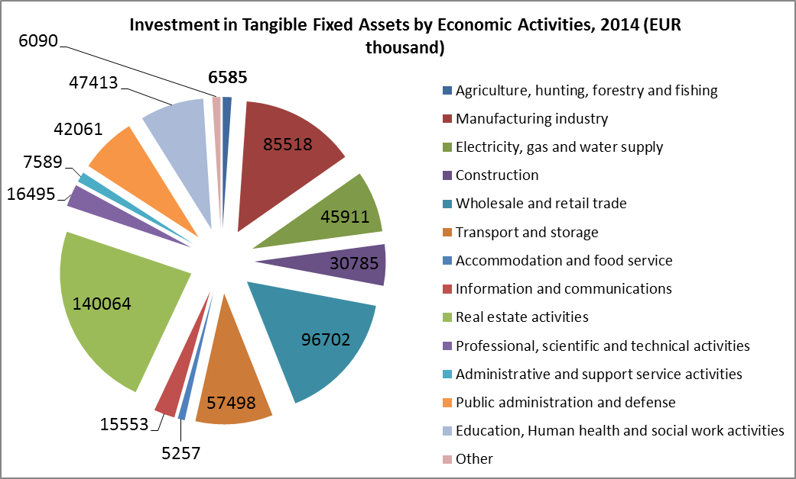

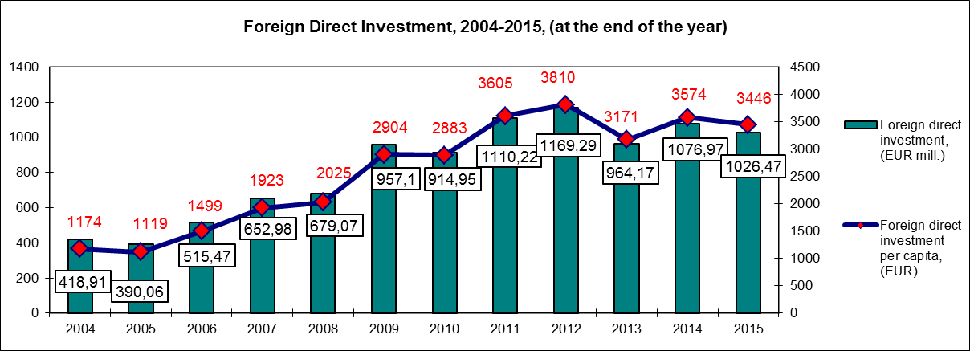

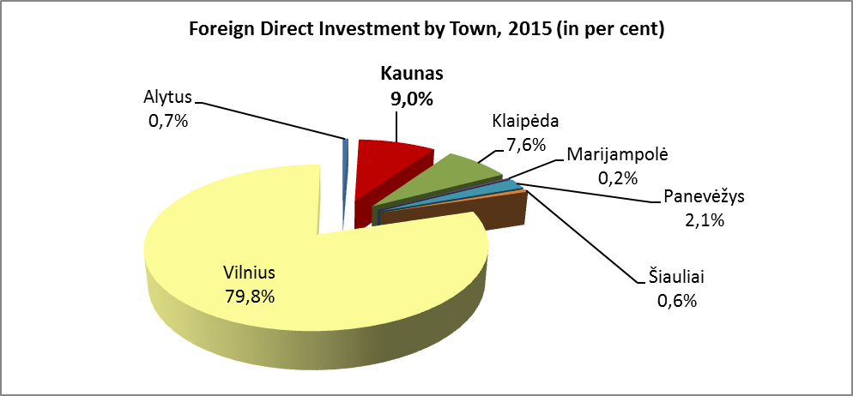

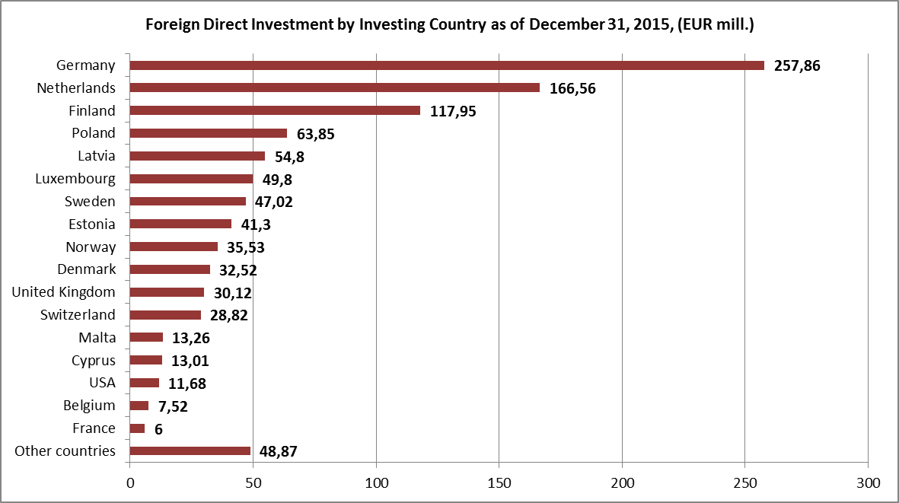

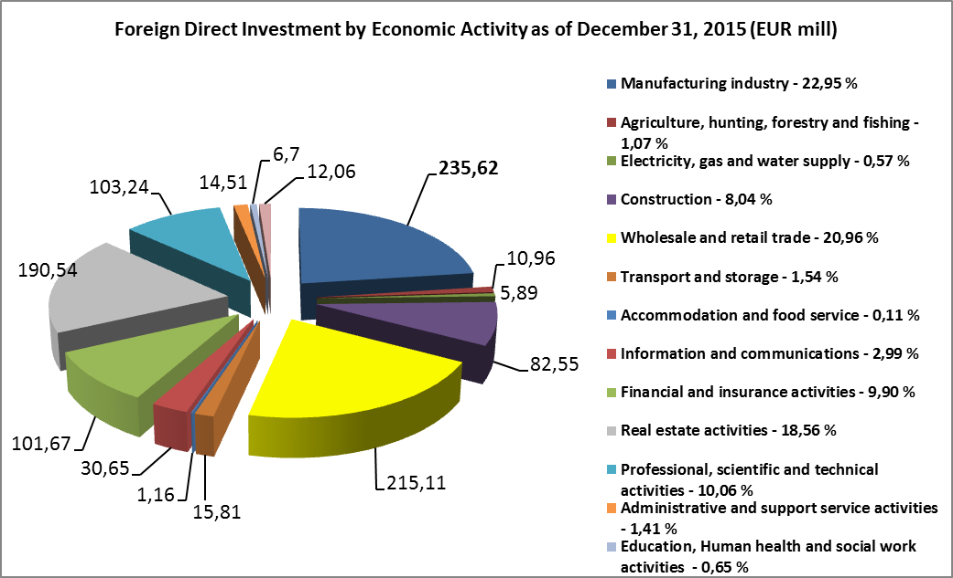

EMPLOYMENT

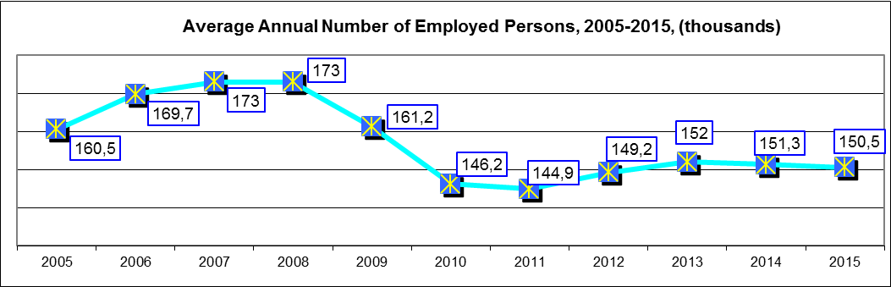

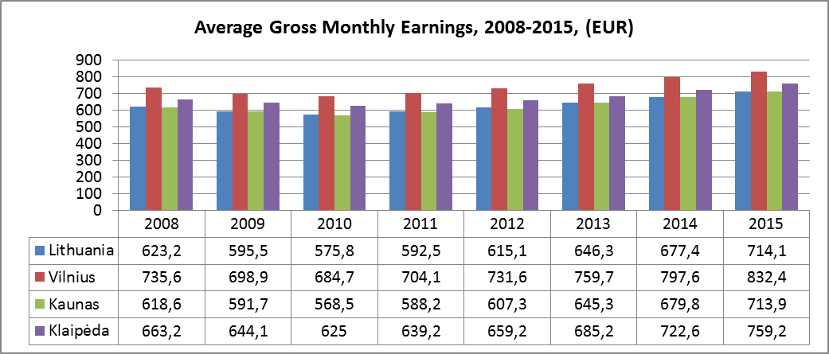

LABOUR MARKET

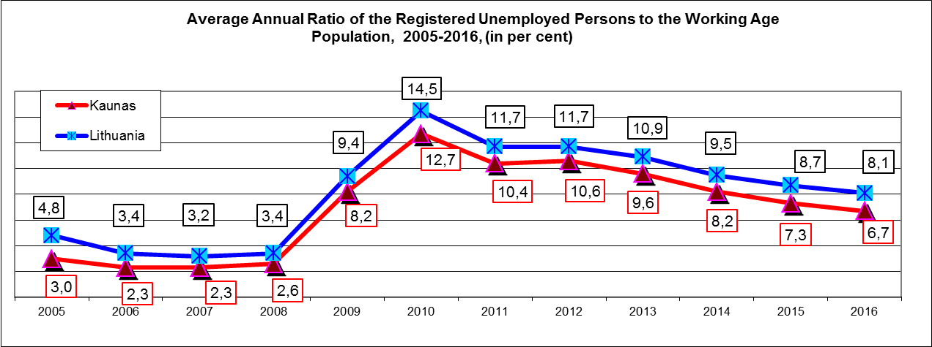

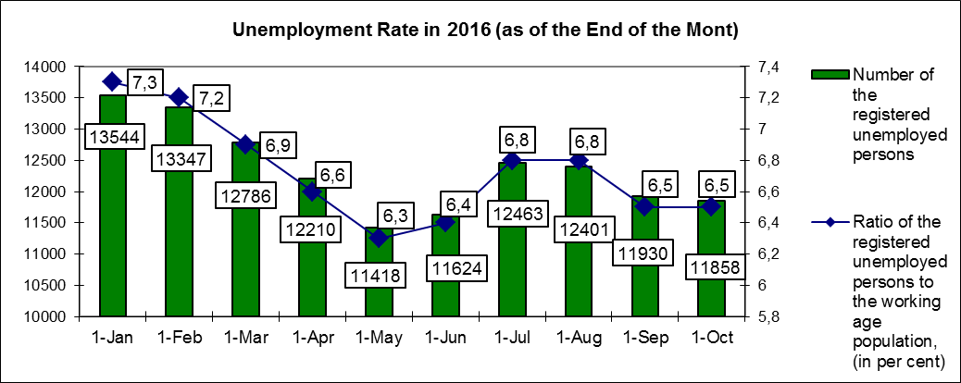

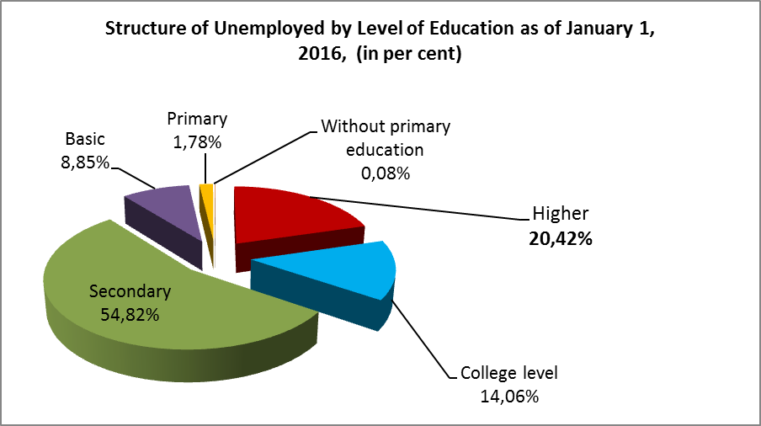

KAUNAS CITY`S MUNICIPAL BUDGET

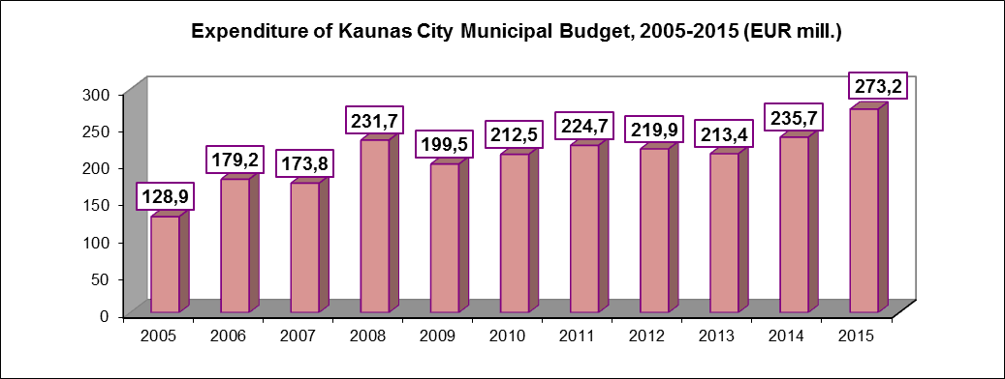

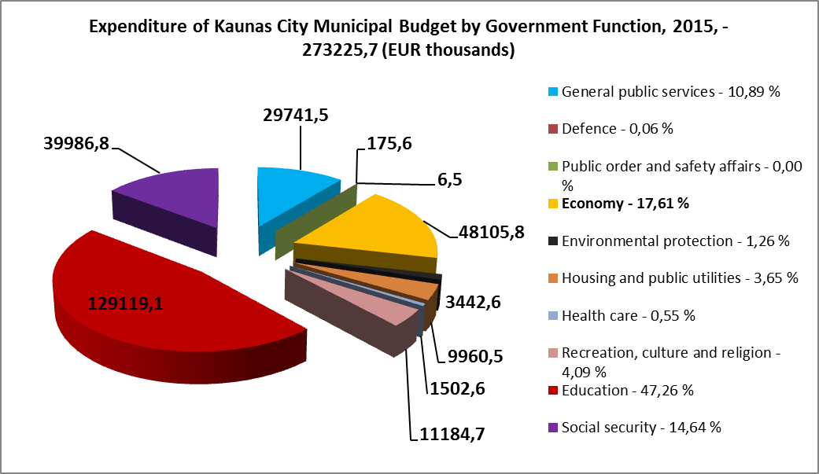

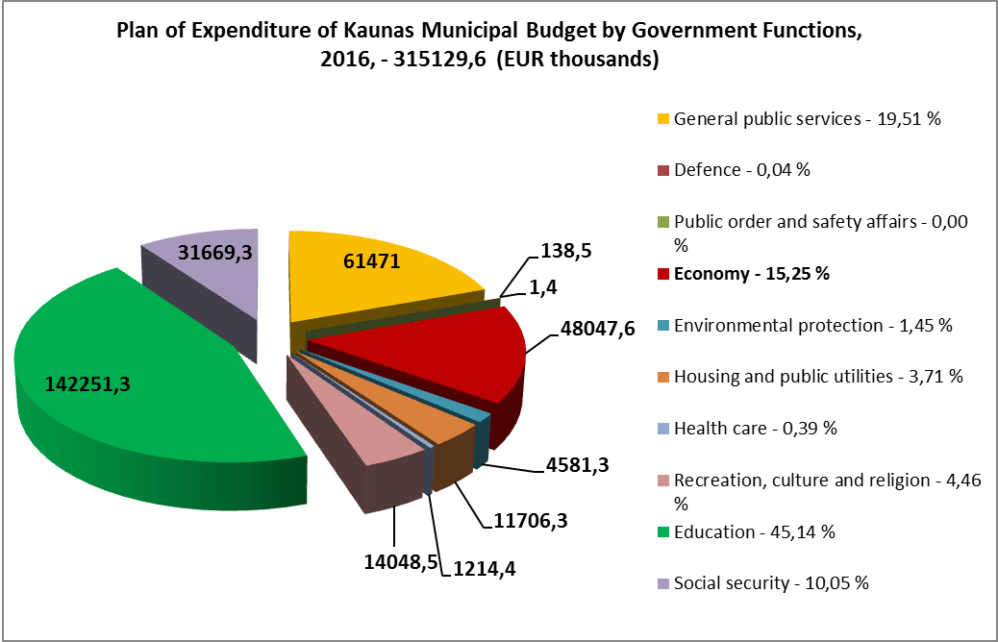

PRICE OF REAL ESTATE IN KAUNAS

Prices of flats (EUR / m²) |  |  | 1 room |  |  | 2 rooms |  |  |  | 3 rooms |  | 4 rooms and +
 |  |  | of | to |  | of |  | to |  | of | to |  |  | of | to
Downtown, Old Town
flats in new building (partial finish) |  |  | 1.300 | 2.200 |  | 1.300 |  | 2.150 |  | 1.250 | 1.900 | 1.150 |  |  | 1.750
restored flats in old buildings |  |  | 1.200 | 1.900 |  | 1.150 |  | 2.000 |  | 1.150 | 1.950 | 1.100 |  |  | 1.900
not restored flats in old buildings |  |  | 930 | 1.550 |  | 870 |  | 1.500 |  | 830 | 1.480 | 780 |  |  | 1.450
Residential areas
flats in new building (partial finish) |  |  | 900 | 1.350 |  | 840 |  | 1.350 |  | 800 | 1.300 | 760 |  |  | 1.160
restored flats in old buildings |  |  | 730 | 1.100 |  | 680 |  | 1.080 |  | 650 | 970 | 600 |  |  | 900
not restored flats in old buildings |  |  | 580 | 800 |  | 550 |  | 760 |  | 520 | 700 | 460 |  |  | 620
Suburbs
flats in new building (partial finish) |  |  | 700 | 900 | 700 |  | 900 |  | 650 |  | 860 |  | 580 |  | 800
Prices of individual houses and townhouse (~150<200 m², EUR) |  |  | New buildings (partial finish) |  |  |  |  |  | Old buildings
 |  |  | of |  |  | to |  |  | of |  |  | to
Downtown and prestigious areas |  |  | 140.000 |  |  | 300.000 |  |  | 130.000 |  |  | 360.000
Residential areas |  |  | 95.000 |  |  | 200.000 |  |  | 90.000 |  |  | 220.000
Suburbs |  |  | 70.000 |  |  | 130.000 |  |  | 65.000 |  |  | 160.000
Rent prices of individual houses and flats (EUR/month) | 1 room |  | 2 rooms |  |  | 3 rooms |  |  | 4 rooms and + |  |  | Individual houses
Rent prices of individual houses and flats (EUR/month) | of | to | of | to |  | of |  | to | of |  | to |  |  | of | to
Downtown, Old Town, Žaliakalnis | 175 | 300 | 240 | 440 |  | 250 |  | 570 | 290 |  | 700 |  |  | 460 | 1.150
Residential areas | 130 | 230 | 175 | 340 |  | 180 |  | 380 | 180 |  | 400 |  |  | 350 | 650
Rent prices of commercial real estate (EUR/ m²/ month, VAT excluded) |  |  | offices |  |  | commercial premises |  |  | modern warehouses |  |  | industrial premises
 |  |  | of | to |  | of |  | to | of |  | to | of |  |  | to
Old Town |  |  | 5,2 | 12,0 |  | 7,2 |  | 16,0 | no supply |  |  | no supply
Downtown (ground floor) |  |  | 5,8 | 13,0 |  | 7,2 |  | 19,0 | no supply |  |  | no supply
Downtown (other floors) |  |  | 5,2 | 11,5 |  | 4,3 |  | 7,5 | no supply |  |  | no supply
Residential areas |  |  | 4,2 | 7,5 |  | 4,1 |  | 6,7 | no supply |  |  | 1,5 |  |  | 3,2
Suburbs and industrial areas |  |  | 3,0 | 3,5 |  | 2,9 |  | 4,1 | 3,5 |  | 1,2 | 1,2 |  |  | 2,6
Prices of commercial real estate (EUR/m², VAT excluded) |  |  | offices |  |  | commercial premises |  |  | modern warehouses |  |  | industrial premises
 |  |  | of | to |  | of |  | to | of |  | to | of |  |  | to
Old town |  |  | 870 | 1.500 |  | 1.000 |  | 2.200 | no supply |  |  | no supply
Downtown (ground floor) |  |  | 980 | 1.900 |  | 1.010 |  | 2.320 | no supply |  |  | no supply
Downtown (other floors) |  |  | 720 | 1.450 |  | 720 |  | 1.300 | no supply |  |  | no supply
Residential areas |  |  | 490 | 1.100 |  | 520 |  | 950 | no supply |  |  | 190 |  |  | 380
Suburbs and industrial areas |  |  | 400 | 520 |  | 350 |  | 550 | 410 600 |  |  | 170 |  |  | 340
Note. Source of data: www.ober-haus.lt . The market-research of December , 2016

